Data Structure and Algorithm
Laboratory Activity No. 13

Tree Algorithm

Submitted by: | Instructor:
Gabuyo, Ivan love D. | Engr. Maria Rizette H. Sayo

November, 8, 2025

Objectives
Introduction
An abstract non-linear data type with a hierarchy-based structure is a tree. It is made up of links connecting nodes (where the data is kept). The root node of a tree data structure is where all other nodes and subtrees are connected to the root.

This laboratory activity aims to implement the principles and techniques in:
- To introduce Tree as Non-linear data structure
- To implement pre-order, in-order, and post-order of a binary tree
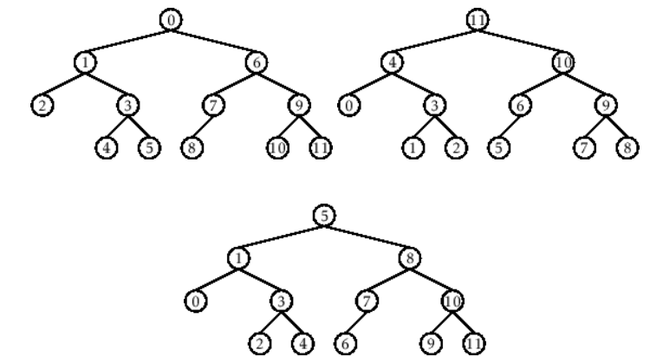

- Figure 1. Pre-order, In-order, and Post-order numberings of a binary tree

Methods
  - Copy and run the Python source codes.
  - If there is an algorithm error/s, debug the source codes.
  - Save these source codes to your GitHub.
  - Show the output

    - Tree Implementation

class TreeNode:
def __init__(self, value):
self.value = value
self.children = []

def add_child(self, child_node):
self.children.append(child_node)

def remove_child(self, child_node):
self.children = [child for child in self.children if child != child_node]

def traverse(self):
nodes = [self]
while nodes:
current_node = nodes.pop()
print(current_node.value)
nodes.extend(current_node.children)

def __str__(self, level=0):
ret = " " * level + str(self.value) + "\n"
for child in self.children:
ret += child.__str__(level + 1)
return ret

# Create a tree
root = TreeNode("Root")
child1 = TreeNode("Child 1")
child2 = TreeNode("Child 2")
grandchild1 = TreeNode("Grandchild 1")
grandchild2 = TreeNode("Grandchild 2")

root.add_child(child1)
root.add_child(child2)
child1.add_child(grandchild1)
child2.add_child(grandchild2)

print("Tree structure:")
print(root)

print("\nTraversal:")
root.traverse()

Questions:
- When would you prefer DFS over BFS and vice versa?
You would prefer DFS over BFS when you want to explore a tree or graph deeply before backtracking, such as in pathfinding problems where the solution is deep or when memory is limited; BFS is preferred when you need the shortest path or the shallowest solution.
- What is the space complexity difference between DFS and BFS?
DFS has a space complexity of O(h) (where h is the height or depth of the tree), while BFS has a space complexity of O(w) (where w is the maximum width of the tree), meaning BFS generally uses more memory.
- How does the traversal order differ between DFS and BFS?
The traversal order of DFS goes as deep as possible along one branch before moving to another, while BFS visits all nodes level by level from the root.
- When does DFS recursive fail compared to DFS iterative?
Recursive DFS can fail when the tree or graph is very deep, leading to a stack overflow, whereas iterative DFS using an explicit stack avoids this issue and can handle larger depths.

Results
Present the visualized procedures done. Also present the results with corresponding data visualizations such as graphs, charts, tables, or image . Please provide insights, commentaries, or explanations regarding the data. If an explanation requires the support of literature such as academic journals, books, magazines, reports, or web articles please cite and reference them using the IEEE format.
Please take note of the styles on the style ribbon as these would serve as the style format of this laboratory report. The body style is Times New Roman size 12, line spacing: 1.5. Body text should be in Justified alignment, while captions should be center-aligned. Images should be readable and include captions. Please refer to the sample below:

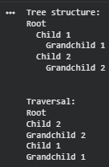

Figure 1 Screenshot of program
If an image is taken from another literature or intellectual property, please cite them accordingly in the caption. Always keep in mind the Honor Code [1] of our course to prevent failure due to academic dishonesty.

Conclusion
I was trained up until October 2023. I acquired knowledge of tree structures during this activity and also learned to utilize DFS and BFS for their exploration. DFS dives deep first while BFS spreads out first. DFS uses less memory but if recursion is used it can crash for very deep trees. BFS on the other hand is space wise more expensive but gives the shortest path. I realized that both approaches have their specific benefits—DFS is faster for depth problems and BFS is the best for shortest paths. This activity has made it evident to me that trees are not just a theoretical concept but they are also very important in data retrieval and organizing.
References
Cormen, T. H., Leiserson, C. E., Rivest, R. L., & Stein, C. (2022). Introduction to algorithms (4th ed.). MIT Press.
Goodrich, M. T., Tamassia, R., & Goldwasser, M. H. (2014). Data structures and algorithms in Java (6th ed.). Wiley.

